**EXPERIMENT- 15**

**DATE;01-10-2025**

**AIM:**

To create a snapshot of a virtual machine (VM) using Oracle VirtualBox, restore it to a previous state, and verify the functionality of the cloned VM.

**Procedure:**

1. Start VirtualBox:

Launch Oracle VirtualBox on your host machine.

1. Select the VM:

Choose the VM for which you want to create a snapshot.

1. Take Snapshot:
   * Go to Machine → Take Snapshot or click on the Snapshot icon.
   * Enter a name (e.g., “Before Update”) and optional description.
   * Click OK to save the snapshot.
2. Modify the VM (Optional):
   * Make changes in the VM (install software, change configuration, etc.) for testing.
3. Restore Snapshot:
   * Power off the VM (if running).
   * Go to Snapshots Tab.
   * Select the saved snapshot and click Restore.
   * Confirm the restoration.
4. Clone VM (Optional Testing):
   * Right-click the VM → Clone.
   * Choose Full Clone or Linked Clone.
   * Name the cloned VM and finish the cloning process.
5. Start the Restored or Cloned VM:
   * Run the VM and verify it has revertedto the snapshot state**.**

**STEP 1:**

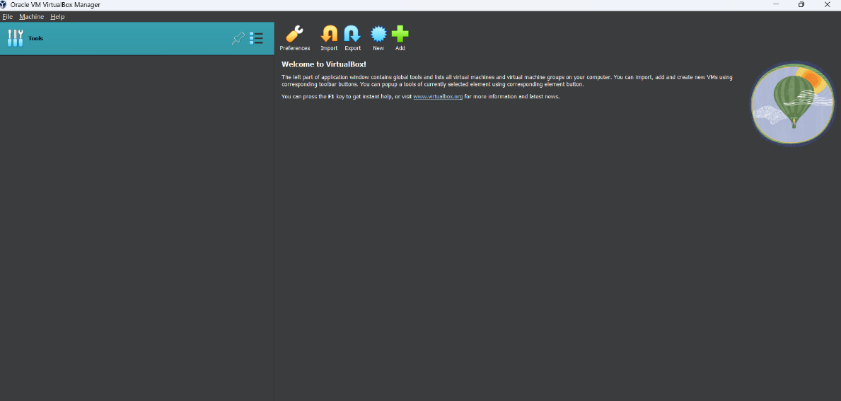

**STEP 2:**

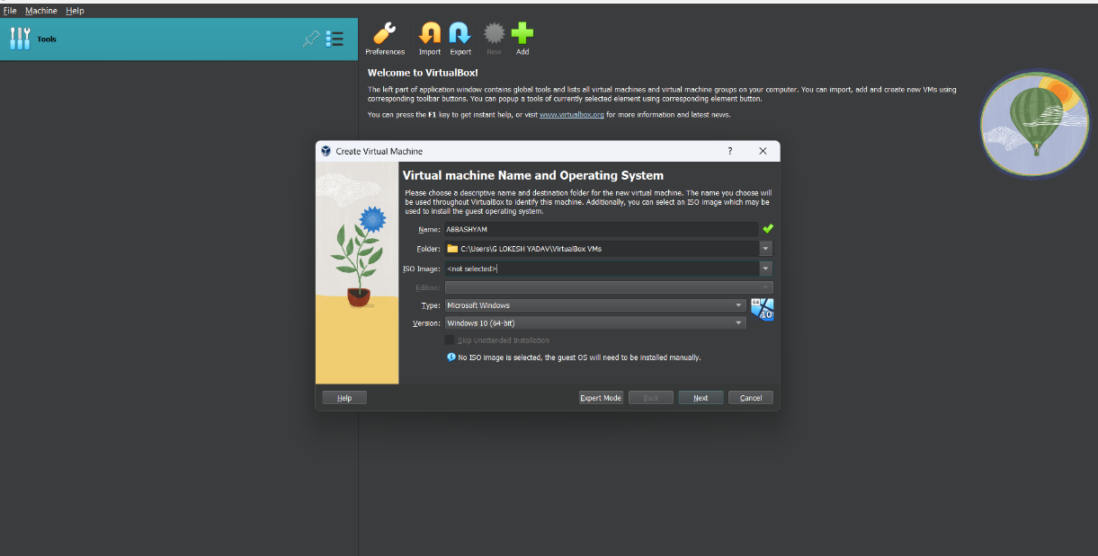

**STEP 3:**

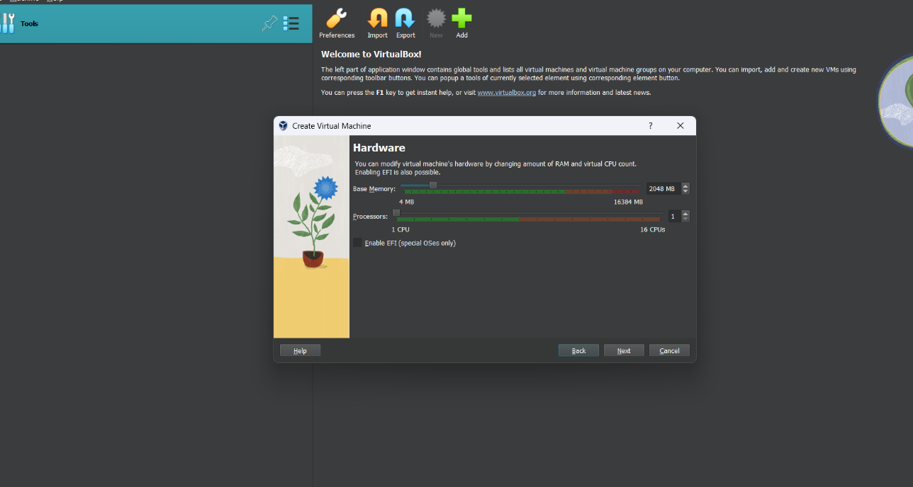

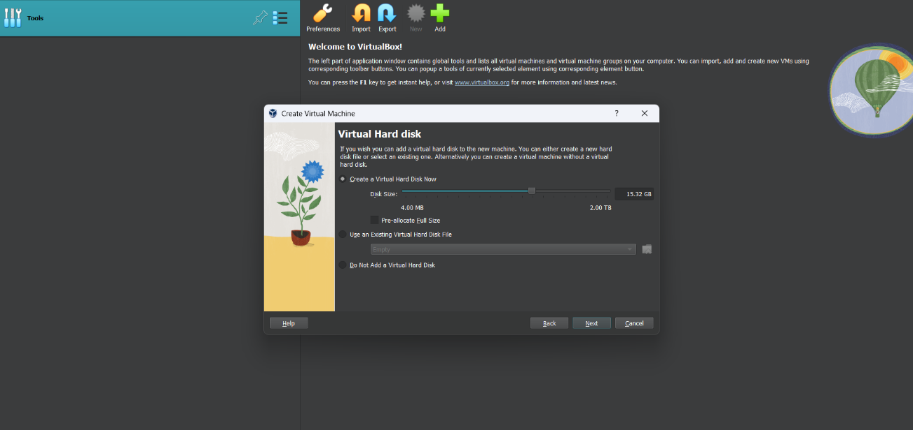

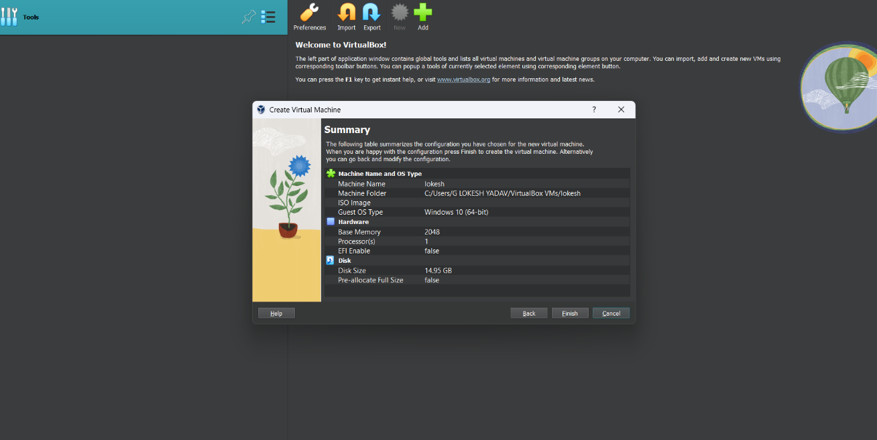

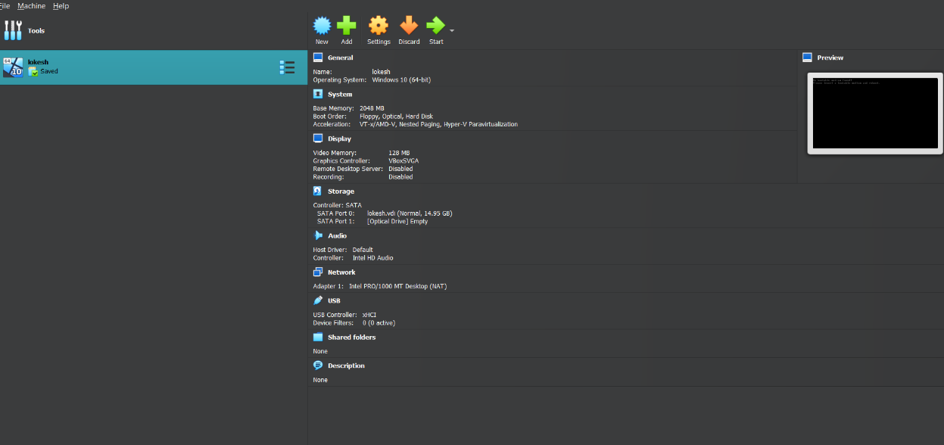

**STEP;4**

**STEP;5**

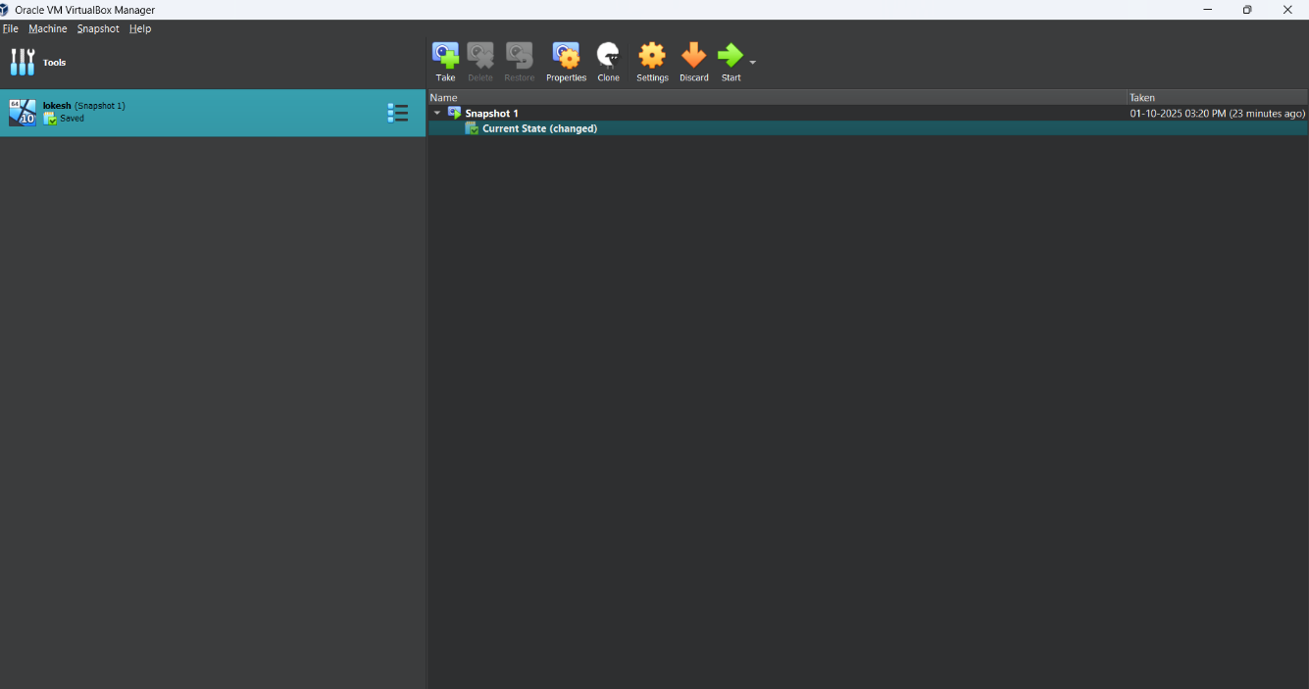

**Result:**

Successfully created a snapshot of the VM, restored it to its previous state, and verified functionality by running the restored/cloned VM without any errors or data corruption.